**Hospital Management System**

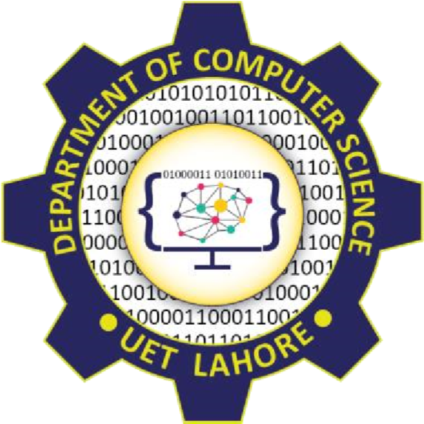

Session: 2022 – 2026

# Submitted by:

Robass Atif 2022-CS-150

# Submitted To:

Prof. Dr. Muhammad Awais Hassan

Department of Computer Science

**University of Engineering and Technology**

**Lahore Pakistan**

Contents

Submitted by: 1

Submitted To: 1

1. Introduction 3

2. Oops Concept 3

Association 3

Inheritance 4

Polymorphism 4

3. Design Pattern 4

BL 4

DL 4

UI 4

4. Conclusion 4

# Introduction

The Hospital Management System (HMS) is a comprehensive software solution designed to streamline and optimize the administrative, clinical, and financial operations within a healthcare facility. This system aims to enhance the overall efficiency, accuracy, and accessibility of managing patient data, medical records, appointments, and other critical aspects of hospital administration.Oops

Concept

## Association

In this project relation between doctor and patient is association. The relation is composition.

## Inheritance

In this project person is parent class while admin, doctor and patient are child class.

## Polymorphism

In this project polymorphism occur in toString() function

# Design Pattern

## BL

In BL, there are three class which is doctor patient and admin

## DL

In DL, there are also three class as described above.

## UI

In UI, there are 5 class

# Conclusion

In conclusion, I want to it was my great achievement and I learnt many thing through this project and in file handling I face great difficulty.